|  |  |
| --- | --- |
| School of Electronic Engineering and Computer Science | **Final Report**  **Programme of study:**  Electrical and Electronic Engineering  **Project Title:**  **Smart Guidance Stick**  **Supervisor:**  Shady Gadoue  **Student Name:**  Harikrishna Soni  Date: 28/04/2024 |
| Final Year  Undergraduate Project 2023/24 |
| QMLogo |

Abstract

Navigation challenges for people with visual impairments are a daily reality, demanding innovative solutions. Traditional walking sticks use tactile-force feedback to detect static obstacles, however, are limited in range and unsuitable for dynamic components. This project aims to develop a Smart Guidance Stick using an Arduino Uno, improving environmental awareness for the visually impaired.

The Smart Guidance Stick uses an ultrasonic sensor to detect obstacles, providing real-time auditory alerts for safer navigation. A rain sensor is used to detect wet surfaces, contributing to a safer travel experience. With the integration of a GPS and GSM module, the stick features an emergency button that, when activated, sends an SMS to the user's designated emergency contact along with their current location.

This project strives to empower visually impaired individuals during independent travel, providing a versatile solution to dynamic obstacles. By using sensors and communication modules, the Smart Guidance Stick not only detects obstacles but ensures a quick and effective response in emergency situations, allowing a greater sense of autonomy and safety for users.

**C**

**ontents**

Chapter 1: Introduction 5

1.1 Background 5

1.2 Problem Statement 6

1.3 Aim 6

1.4 Objectives 6

1.5 Report Structure 7

Chapter 2: Literature Review 8

2.1 Basic White Cane 8

2.2 Infrared Sensor Stick 8

2.3 Electronic Travelling Aid 9

2.4 Intelligent Guide Stick with MELDOG CPU 10

2.5 Comparative Analysis 10

Chapter 3: Methodology 13

3.1 Conceptual Framework 13

3.2 List of Components 14

3.3 Table of costs 25

3.4 Block Diagram of System 26

3.5 Flow Diagram of System 27

3.6 Circuit Diagram of Smart Guidance Stick 28

3.7 Initial Schematic of Smart Guidance Stick 29

3.8 Software Development 30

Chapter 4: Presentation 33

4.1 Source Code 33

Chapter 5: Evaluation 34

Chapter 6: Conclusion 35

References 36

Appendix A - Example 42

Additional Appendices (as needed) 43

# Introduction

## Background

Visual impairment is a term broadly used to describe conditions that result in a loss of vision, limiting an individual's ability to see and interpret visual information. It includes a range of visual disabilities, such as blurred vision, characterised by a lack of sharpness and clarity in the perception of objects, tunnel vision, which restricts the field of view, and total blindness, where visual information is entirely absent. These conditions significantly impact daily life and independence. The leading causes of visual impairment include refractive errors, diabetic retinopathy, cataracts, glaucoma, and age-related macular degeneration. Uncorrected refractive error is a global issue that is of great concern as it is the leading cause of vision impairment in all age groups, from children to adults [1].

Visual impairment poses a global challenge, impacting the lives of an estimated 1.1 billion individuals. Within this statistic, 295 million people experience moderate to severe visual impairment, and an additional 43 million are classified as blind, as reported by the International Agency for the Prevention of Blindness (IAPB) in 2020 [2]. Projections from the IAPB indicate a concerning trajectory, forecasting a rise to 1.7 billion individuals struggling with visual impairment by the year 2070.

A visually impaired person often relies on traditional walking sticks (white cane), which provide tactile feedback for detecting static obstacles. However, it has its limitations, especially in identifying dynamic obstacles and providing comprehensive real-time environmental feedback. As a result, visually impaired individuals face increased risks and limitations in their ability to move confidently and safely. Guide dogs offer valuable assistance, but they come with their own challenges, including potential allergies, the demanding training process, financial constraints, space considerations, the limited lifespan of the dog, adaptation difficulties in new environments, and an inability to convey specific information about surroundings.

In response, a Smart Guidance Stick is proposed to enhance the independence of visually impaired individuals. This device, equipped with an ultrasonic and rain sensor, alerts users of obstacles and water hazards, reducing the risk of accidents. Additionally, the GPS and GSM modules enable location tracking and emergency communication features for further safety. By providing artificial vision, it aims to empower visually impaired individuals for safer and more confident daily mobility.

## Problem Statement

Despite the availability of traditional walking sticks and other mobility aids, visually impaired individuals encounter significant challenges in navigating their surroundings independently and safely. The existing solutions, such as white canes, primarily focus on providing tactile feedback for detecting static obstacles. However, these aids prove limited when it comes to identifying dynamic obstacles and offering real-time environmental feedback.

The limitations of current mobility aids contribute to heightened risks and restrictions for visually impaired individuals during daily travel. The inability to detect dynamic obstacles in real-time lowers their confidence and safety, making independent mobility a formidable challenge. As evidenced by recent studies, the risk of accidents remains high amongst this demographic, with many reporting frequent near misses involving dynamic obstacles [3]. While guide dogs offer valuable support, they too present obstacles, including potential allergies, a demanding training process, financial constraints, and limitations in conveying specific information about the surroundings.

## Aim

The aim of this project is to develop a Smart Guidance Stick, overcoming the limitations of conventional walking sticks, guide dogs and other mobility aids designed for visually impaired individuals. The Smart Guidance Stick aims to improve spatial awareness for users by providing immediate auditory feedback about nearby obstacles and water hazards. The stick will also include an emergency button that, when pressed, immediately sends the user’s location to their emergency contact, ensuring assistance when needed.

## Objectives

To fulfil the project aims, the following specific objectives need to be achieved:

1. Design and create an Arduino-based Smart Guidance Stick that is fully automated, easy to maintain, and comfortable to use.
2. Sensor Integration:
   1. Implement ultrasonic sensors to detect obstacles to enhance spatial awareness.
   2. Implement a rain sensor to detect wet surfaces, preventing potential slips.
3. Real-time alert system:
   1. Develop a buzzer-based alert system to deliver real-time auditory signals for:
      1. Obstacle detection
      2. Wet surface detection
4. Emergency Response System:
   1. Implement an emergency button on the Smart Guidance Stick.
   2. Use a GPS module to accurately determine the user’s location.
   3. Use a GSM module for immediate SMS communication.
   4. Create a system to send the user's location to a designated emergency contact at the press of the emergency button.
5. Conduct user testing and implement their feedback onto the stick.

## Report Structure

### Literature Review

Chapter 2 provides insights into existing mobility aids for the visually impaired, such as the Basic White Cane, Electronic Travelling Aid, Infrared Sensor Stick, and Intelligent Guide Stick with MELDOG CPU. Each aid's advantages and disadvantages are summarised, offering a comprehensive overview of available technologies.

### Methodology

Chapter 3 establishes the conceptual framework for the Smart Guidance Stick project, focusing on independence, safety, sensor fusion, real-time responsiveness, user-centric design, emergency response, and accessibility. It outlines key components, including Arduino Uno, Ultrasonic sensor (HC-SR04), GPS Module (NEO-6M), GSM Module (SIM 900), Rain Sensor (Haljia), and Buzzer, with specifications provided. The chapter features visual representations, including a block diagram, flow diagram, and schematic, enhancing understanding of the project's structure and functionality.

# Literature Review

## Basic White Cane

The basic white cane is the most widely used mobility aid by visually impaired individuals. It operates on a purely mechanical basis, utilising tactile-force feedback mechanisms. Its primary function is the detection of static obstacles such as those found on the ground or uneven surfaces, and it is versatile enough for both indoor and outdoor use. The cane’s operation does not depend on lighting conditions, making it equally useful during both day and night. However, its reliance on physical contact for feedback limits its effective range and makes it less effective in identifying dynamic obstacles, such as moving vehicles or people, which can pose significant challenges to users in busy or complex environments [3].

**Advantages:**

* **Simplicity:** The basic white cane’s mechanical design is straightforward, making it easy to use and accessible for visually impaired individuals.
* **Portability:** Its lightweight design enhances portability, allowing users to carry it with convenience during daily activities.
* **Cost-Effective:** The basic white cane is generally cost-effective compared to more complex technological alternatives.

**Disadvantages:**

* **Limited Range:** The cane’s tactile feedback is only effective within a short range, which may not suffice for detecting obstacles that are further away.
* **Inability to Detect Dynamic Obstacles:** It is primarily designed for static environments and struggles with identifying moving obstacles, such as walking pedestrians or approaching vehicles.

## Infrared Sensor Stick

The infrared (IR) sensor stick is a specialised assistive device designed to improve mobility for visually impaired individuals. It uses strategically placed dual infrared sensors – one positioned horizontally to detect obstacles directly in front of the user up to 200cm, and the other inclined to detect ground level hazards such as stairs and curbs. These sensors detect the thermal signatures of objects and use this data to navigate complex environments. The collected data is processed by a 16F877A microcontroller, which compares the transmitted and received infrared signals to determine the presence and proximity of obstacles. The system is designed to provide real-time feedback, alerting users through auditory signals delivered via earphones or tactile feedback, thus significantly improving the user's ability to navigate safely and effectively [5].

**Advantages:**

* **Distance Calculation Capability:** The IR sensor stick is adept at calculating the distance to obstacles, providing essential spatial information to help users navigate.
* **Cost-Effectiveness:** The IR sensor stick is designed to be affordable, making it accessible for many visually impaired individuals.

**Disadvantages:**

* **Short-Ranged Performance:** The detection range is limited; this can be a drawback in situations where early warning of distant obstacles is crucial for safe navigation.
* **Environmental Sensitivity:** The sensors are susceptible to environmental influences such as direct sunlight or other heat sources, which can reduce signal accuracy and, consequently, the reliability of the stick.

## Electronic Travelling Aid

The Electronic Travelling Aid is a significant leap forward in assistive technology for visually impaired individuals [4]. This system utilises an embedded eBox 2300 with an X86 processor, which interfaces with ultrasonic sensors and a USB webcam to detect both obstacles and human presence. By processing distance data along with visual inputs, the device offers auditory feedback through headphones, improving spatial awareness. It detects obstacles both near and far, as well as human recognition capabilities through analysis of facial and clothing texture. The user can manually operate the system, which includes controls for distance measurement, human detection, and motion detection, all powered by batteries and carried in a waist bag.

**Advantages:**

* **Good detection:** Combines ultrasonic and visual data from the camera for comprehensive obstacle identification, ensuring safer navigation. This allows for dynamic obstacle detection.
* **Technological Integration:** Adapts to various environments with its advanced technology, offering greater situational awareness.

**Disadvantages:**

* **Complexity:** The use of multiple technologies may increase the learning curve for users.
* **Cost:** More expensive than simpler aids due to its advanced components.
* **Maintenance:** Requires regular updates and maintenance to ensure optimal functionality.

## Intelligent Guide Stick with MELDOG CPU

The intelligent guide stick represents another technological leap in assistive technology for the visually impaired, incorporating an array of sensors and computational technology [6]. The core of this technology is an intelligent CPU named MELDOG, which integrates artificial intelligence functionalities. The stick is equipped with a combination of ultrasonic and laser sensors for precise obstacle detection. It uses a ‘map matching technique’ to accurately determine its position. It is equipped with a DC motor controller connected to an encoder, which updates location data as the wheels rotate by 18 degrees. Additionally, infrared sensors on both wheels enhance continuous detection within a 0 to 18-degree angle. When combined, these components enable the stick to detect obstacles and follow pre-determined paths.

**Advantages:**

* **Accurate Obstacle Positioning:** The intelligent guide stick uses ultrasonic and laser sensors, ensuring precise obstacle detection.

**Disadvantages:**

* **Cost:** The technology integrated into the system makes it significantly more expensive than the other models.
* **Complexity:** The complexity of the system may pose challenges, especially for users not accustomed to advanced technology.
* **Weight:** Compared to similar systems, this intelligent guide stick is notably heavy, weighing around 5.5 Kg, potentially affecting user comfort.
* **Limited Detection Range:** The detection distance of the system is relatively low.

## Comparative Analysis

This comparative analysis evaluates the functionality and effectiveness of the mobility aids mentioned above and contrasts them with the Smart Guidance Stick. The aim is to delineate how the Smart Guidance Stick addresses the limitations of traditional and modern mobility aids.

1. **Technology and Obstacle Detection**
   * + **Basic White Cane:** Uses simple tactile feedback to detect immediate static obstacles. Lacks any electronic or sensory technology to detect dynamic obstacles.
     + **Infrared Sensor Stick:** Uses infrared sensors to detect obstacles based on thermal signatures, effective in detecting heat signatures but the sensors are prone to inaccuracies in environments where temperature and lighting fluctuations occur. It also has a limited range of detection.
     + **Electronic Travelling aid:** While the combination of ultrasonic sensors and a USB camera allows for advanced obstacle detection, the reliance on visual data may lead to challenges in accurately identifying obstacles, especially in low-light conditions or environments with complex visual cues.
     + **Intelligent Guide Stick with MELDOG CPU:** Combines two DC motors, a microcontroller, and an ultrasonic sensor. Accurate in obstacle positioning but with a limited range.
     + **Smart Guidance Stick:** Uses ultrasonic sensors for real-time, dynamic obstacle detection across a wide range of conditions, surpassing traditional and other advanced methods by providing enhanced range, reliability, and adaptability without relying on environmental conditions or complex sensor setups.
2. **Environmental adaptability**
   * **Basic White Cane:** Effective in indoor and simple outdoor environments but lacks sensory adaptation to complex environments.
   * **Infrared Sensor Stick**: Performance is dependent on environmental lighting and temperature, which can affect detection accuracy.
     + **Electronic Travelling aid:** Although it uses a combination of ultrasonic sensors and a USB camera for advanced detection, its effectiveness may decrease in poorly lit areas. This happens as cameras require sufficient light to accurately capture and process images.
   * **Intelligent Guide Stick with MELDOG CPU:** Effective in controlled environments; the complex sensors may not perform as well in crowded or highly dynamic areas.
   * **Smart Guidance Stick:** Ultrasonic sensors ensure reliable obstacle detection regardless of lighting conditions, making it effective in both dimly lit and bright environments. Additionally, its ability to detect changes in surface conditions, such as wet areas, offers users enhanced navigation and safety in various weather conditions. Unlike other aids that may struggle in dynamic or complex settings, the Smart Guidance Stick maintains consistent performance.
3. **User accessibility and feedback mechanisms**
   * **Basic White Cane:** Extremely user-friendly due to its simplicity; no learning curve involved. Provides only direct physical feedback which is limited to tactile sensations.
   * **Infrared Sensor Stick:** Provides auditory or tactile feedback, relatively easy to use for those with minimal technological expertise.
   * **Electronic Travelling Aid:** Offers audio feedback through headphones, which can be a learning curve for some users; manual controls enhance user interaction but require familiarity.
   * **Intelligent Guide Stick with MELDOG CPU:** Despite its precision, the complexity of its feedback mechanisms may overwhelm users not accustomed to technological devices.
   * **Smart Guidance Stick:** The Smart Guidance Stick combines simple tactile feedback with intuitive audio alerts in an easy-to-use interface. Designed to minimise the learning curve, it makes advanced navigational aids accessible to more users. Unlike other systems that may seem overwhelming due to their complexity, the Smart Guidance Stick strikes a balance between functionality and user-friendliness, ensuring it is approachable for all users without being intimidating.
4. **Cost effectiveness**
   * **Basic White Cane:** The most cost-effective option, widely accessible due to its low price and minimal maintenance requirements.
   * **Infrared Sensor Stick**: Cost-effective but limited in functionality.
     + **Electronic Travelling Aid:** Higher cost due to advanced sensors and computing hardware. It is potentially less economically accessible for widespread adoption.
   * **Intelligent Guide Stick with MELDOG CPU:** High initial cost and maintenance which makes it less accessible for many users.
   * **Smart Guidance Stick:** Aims to balance advanced functionality with cost-effectiveness, making it accessible everyone.

This analysis shows that while each technology offers certain advantages, they also possess limitations. The Smart Guidance Stick aims to incorporate the practical functionalities of these devices while addressing their shortcomings through advanced yet cost-effective sensor integration, user-friendly design, and robust environmental adaptability.

# Methodology

## Conceptual Framework

The conceptual framework of the Smart Guidance Stick project is built upon several key principles and design considerations, aimed at addressing the challenges faced by visually impaired individuals in navigating their surroundings. The primary elements of the conceptual framework include:

**3.1.1 Independence and Safety**

The goal of the Smart Guidance Stick is to enhance the independence and safety of visually impaired individuals during daily mobility. By providing real-time environmental feedback and an effective alert system, the device empowers users to navigate confidently, reducing the risks associated with obstacles and water hazards.

**3.1.2 Sensor Fusion**

The conceptual framework relies on sensor fusion as a fundamental principle. Integrating an ultrasonic sensor, rain sensor, GPS, and GSM module allows the Smart Guidance Stick to gather data about the environment. This multi-sensor approach ensures comprehensive perception, enabling the device to detect obstacles, and wet surfaces, and communicate the user's location effectively.

**3.1.3 Real-time Responsiveness**

The Smart Guidance Stick is designed to provide immediate feedback to the user upon detecting obstacles or water bodies. This real-time aspect enhances the user's awareness and allows for prompt decision-making, contributing to a safer navigation experience.

**3.1.4 User-Centric Design**

The Smart Guidance Stick aims to be user-friendly, comfortable, and easy to maintain. The placement of sensors and the overall form should prioritise the user’s needs and preferences.

**3.1.5 Emergency Response Mechanism**

Ensuring user safety, the emergency response mechanism is a key part of the conceptual framework. The integration of a dedicated emergency button, GPS, and GSM modules enables swift communication of the user's location to a designated contact in case of an emergency.

**3.1.6 Accessibility and Affordability**

By using commonly available components, such as the Arduino Uno, and prioritising simplicity in design, the Smart Guidance Stick aims to be an accessible solution for a wide range of visually impaired individuals.

## List of Components

### Arduino Uno R3

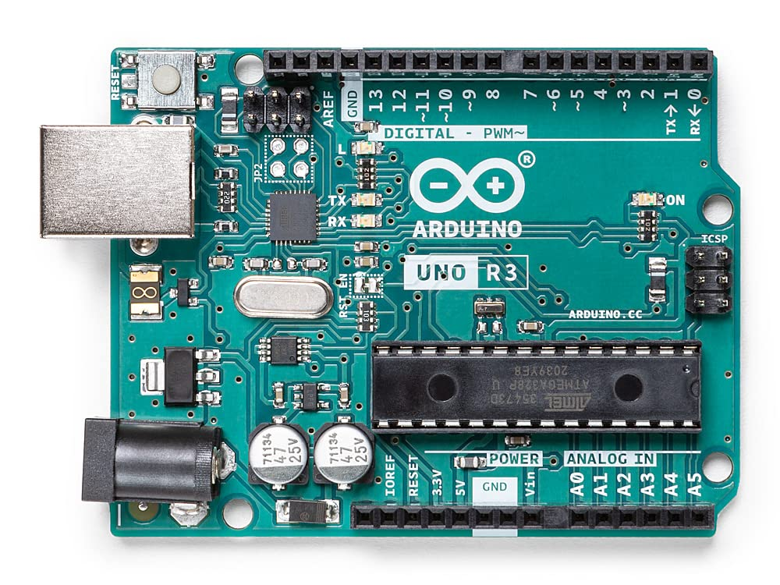

Figure 1: Arduino Uno R3

**Purpose and function in project:**

The Arduino Uno is the core microcontroller board for the Smart Guidance Stick project. It was specifically chosen for its ease of use and versatility in connecting various sensors and modules. The microcontroller on the Arduino Uno is also programmable using the Arduino software development environment [7]. In this project, the Arduino Uno R3 is crucial for coordinating the inputs and outputs of the connected devices, processing sensor data, and executing the control logic that dictates the device's responses.

**Integration in System:**

* Sensor Data Processing: It collects and processes signals from the ultrasonic sensor to determine obstacle distances and from the rain sensor to detect wet surfaces.
* Response Activation: It controls the buzzer to emit auditory signals based on sensor readings, indicating proximity to obstacles or wet areas.
* Communication Management: Handles signals from the GPS and GSM modules to perform location tracking and emergency communication functions.

### Ultrasonic sensor (HC-SR04)

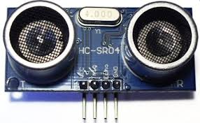

Figure 2: HC-SR04 Ultrasonic sensor

**Purpose and function in project:**

The ultrasonic sensor is used to identify obstacles. The HC-SR04 ultrasonic sensor uses SONAR technology for precise distance measurement, covering a range from 2 cm to 400 cm. This range ensures that the stick will have a broad range of detection. Recognised for its stability and accuracy, this sensor functions effectively irrespective of sunlight or black materials [8].

**Integration in System:**

* Distance Measurement: It sends ultrasonic waves that bounce off nearby objects and return to the sensor. The Arduino calculates the distance to these objects based on the time it takes for the echoes to return.
* Obstacle Detection Alerts: Upon detecting an object within a predetermined distance, the sensor triggers an auditory alert through the buzzer, informing the user of potential obstacles in their path.

### GPS Module (NEO-6M)

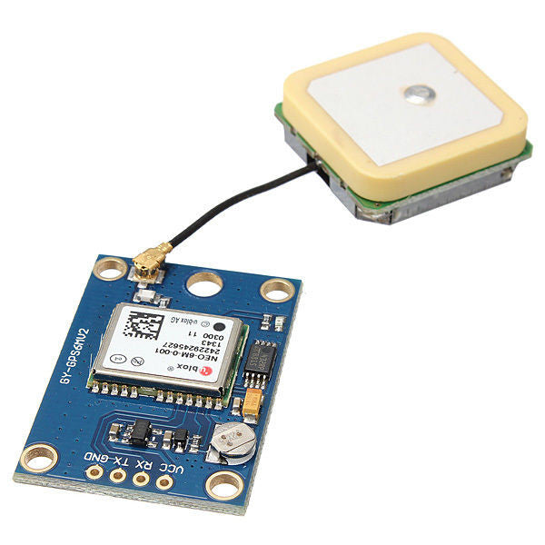

Figure 3: NEO-6M GPS

**Purpose and function in project:**

The NEO-6M GPS module is used in the Smart Guidance Stick for its precision in location tracking. As a satellite-based navigation system, it locks onto signals from orbiting satellites, achieving a Time-To-First Fix (TTFF) of under 1 second. This rapid TTFF ensures swift and accurate positioning for effective navigation [9]. This module is essential for providing geographical positioning information, crucial for the emergency response feature of the device. It offers the ability to determine the user's exact location, which can be communicated to emergency services or caregivers when the user is in need.

**Integration in System:**

* Location Data Acquisition: The GPS module receives signals from global positioning satellites to find the user’s current coordinates. This data is crucial for the emergency features of the Smart Guidance Stick.
* Emergency Communication: In conjunction with the GSM module, the GPS coordinates are used to send an SMS containing the user's location to a predefined emergency contact or responder, facilitating prompt assistance.
* Data Processing: The Arduino Uno processes this location data and determines when an emergency signal should be triggered based on user input (e.g., pressing an emergency button).

### GSM Module (SIM 800L V2)

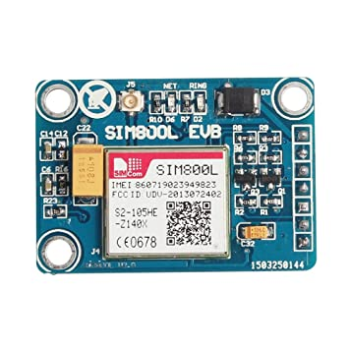

Figure 4: SIM 800L V2 GSM

**Purpose and function in project:**

The SIM800L V2 GSM module is an essential component of the Smart Guidance Stick, chosen for its capability in wireless communication. This module allows the device to send SMS messages, providing a critical communication link between the user and external help in emergency situations. This module supports 2G communication and operates on quad-band frequencies and connects to the Arduino Uno through standard USART protocol [10].

**Integration in System:**

* Emergency SMS: Upon activation (e.g., pressing an emergency button), the GSM module sends an SMS to a pre-configured emergency contact number, which includes the GPS coordinates obtained from the NEO-6M module. This ensures that help can be directed precisely to the user’s location.
* Real-Time Communication Setup: Configures and maintains the connection to the GSM network, ensuring that the device can always send an alert when needed, subject to network availability.

### Rain Sensor (Haljia)

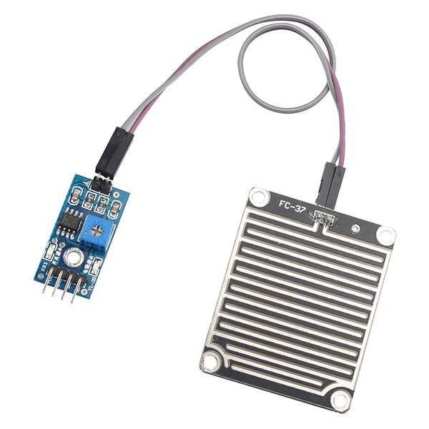

Figure 5: Haljia Rain Sensor

**Purpose and function in project:**

The Haljia Rain Sensor is added onto the Smart Guidance Stick to detect the presence of water on surfaces. This feature is crucial for warning the user about potentially slippery conditions, increasing safety during navigation in various weather conditions.

**Integration in System:**

* Water Detection: The sensor detects moisture by measuring the conductivity between its probes. A lower reading indicates more moisture [11]. This input triggers a specific response from the system to alert the user of wet conditions.
* Alert System: Upon detecting moisture, the Arduino processes this information and activates an auditory alert (a different buzzing pattern compared to the ultrasonic sensor) to inform the user of the hazardous slippery surface ahead.

### Buzzer (Piezo)

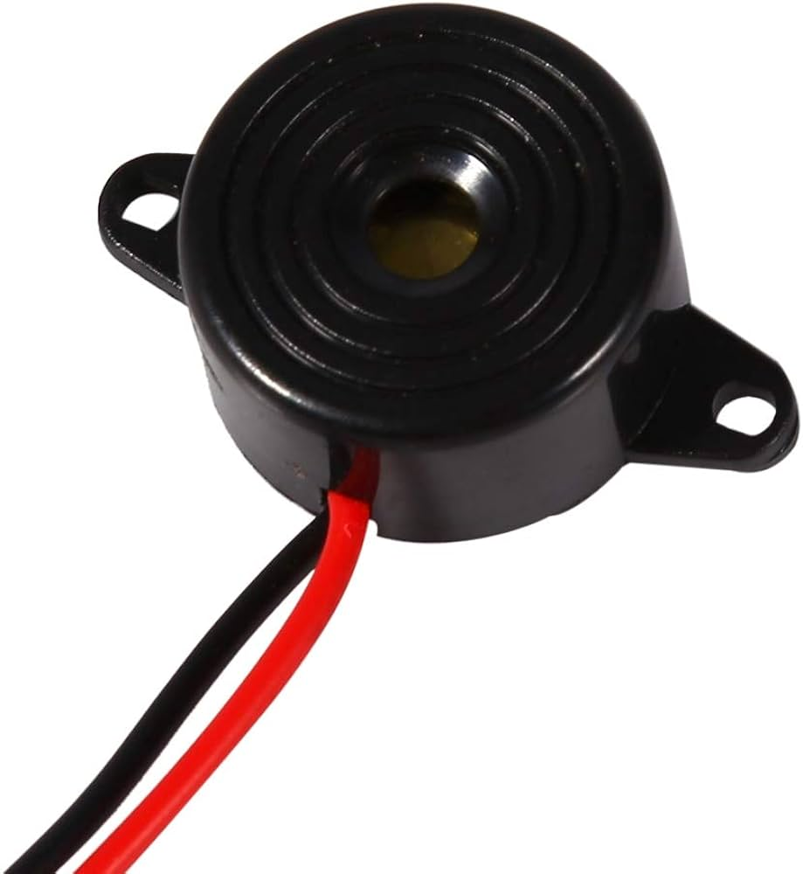

Figure 6: Piezo Buzzer

**Purpose and function in project:**

The Piezo Buzzer is an essential component used primarily for providing auditory alerts to the user. It serves as an effective auditory feedback mechanism that alerts users to various conditions detected by the stick, such as proximity to obstacles or wet surfaces.

**Integration in System:**

* Alert Activation: The buzzer is activated when the ultrasonic sensor detects an obstacle within a specific range, or when the rain sensor detects moisture, emitting a distinct sound pattern for each type of alert.
* Feedback Mechanism: It provides immediate auditory feedback to the user, which is crucial for navigational assistance, especially in noisy outdoor environments where tactile feedback may be insufficient.

### Power Bank (AsperX)

Figure 7: Power Bank

**Purpose and function in project:**

The power bank provides a portable power source for the Smart Guidance Stick, ensuring that all electronic components, including sensors, the GPS module and the GSM module have a reliable supply of energy during operation. This specific power bank provides 5V and 3A current, this is a must to have all components working.

**Integration in System:**

* Energy Supply: It powers the Arduino Uno, which in turn controls and powers the ultrasonic sensor, rain sensor, GPS module, GSM module, and other active components like the Piezo Buzzer.
* Portability and Mobility: Its compact size and capacity are chosen to balance the need for sufficient power supply with the requirement for the device to be lightweight and easy to handle.

### 4110-40, 200mm Jumper Wire Breadboard Jumper Wire in Black, Blue, Brown, Green, Grey, Orange, Purple, Red, White, Yellow | RS Jumper Wires

Figure 7: Power Bank

**Purpose and function in project:**

Jumper wires are integral to the Smart Guidance Stick, used for establishing connections between the various electronic components.

**Integration in System:**

* Versatile Connectivity: They connect the Arduino to the ultrasonic sensor, GPS module, GSM module, Piezo buzzer, and any other electronic components involved in the project.
* Flexibility in Design: Allow for quick changes and adjustments in the circuit without the need for soldering.

### Button

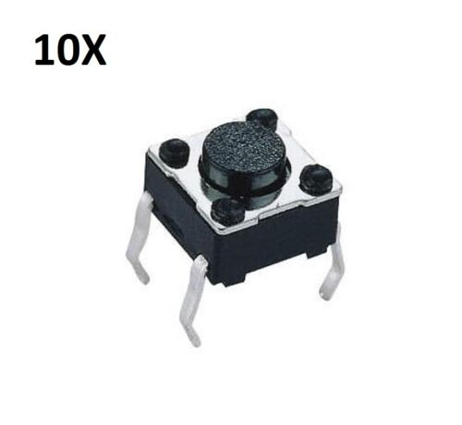

Figure 7: Power Bank

**Purpose and function in project:**

The button switch serves as a critical user interface component, used for activating the emergency communication feature.

**Integration in System:**

* Activation of Emergency Features: Upon pressing the button, it triggers a predefined function in the Arduino's software to initiate communication procedures. This includes gathering the current GPS coordinates and sending an SMS through the GSM module.
* User Accessibility: Designed to be easily accessible and simple to use, the button provides immediate feedback to users through a tactile click, confirming that the press has been registered, which is crucial for visually impaired users.
* Reliability and Durability: The switch is selected for its durability and reliability under frequent use, ensuring that it can withstand the physical demands of daily operation without failure.

### Breadboard

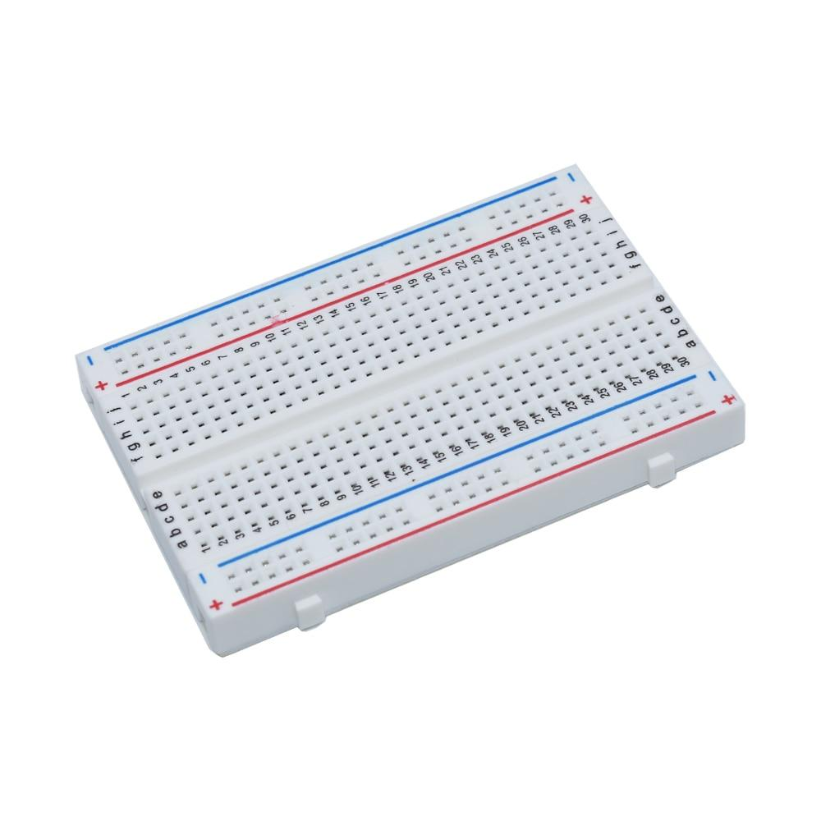

Figure 7: Power Bank

**Purpose and function in project:**

The breadboard is essential as it ensures that the Smart Guidance Stick can evolve based on testing results and user feedback without requiring permanent hardware changes, which can be costly and time consuming.

**Integration in System:**

* Flexibility: Allows for quick changes and iterations in the circuit design, enabling testing of various component arrangements.
* Scalability and Modifications: Allows adjustments and scalability of the electronic system as new components are added or existing ones are modified.

### Walking Stick

Figure 7: Power Bank

**Purpose and function in project:**

The walking stick is used to support all the electronic components integrated onto the device. It not only functions as a traditional mobility aid to help visually impaired users navigate their environment but also acts as a mount for the technological enhancements like sensors, the control unit, and user interface elements.

**Integration in System:**

* Component Mounting: Provides a stable and secure platform for mounting electronic components such as the Arduino Uno, ultrasonic sensor, rain sensor, GPS module, GSM module, and the emergency button. Special attention is paid to the placement of components to ensure balance and ergonomic usability.
* User Interface Accessibility: Designed to ensure that controls and feedback devices, such as the button switch and buzzer, are within close range of the user to enhance accessibility and ease of use.

## Table of costs

|  |  |  |  |  |
| --- | --- | --- | --- | --- |
| Component | Quantity | Price (GBP) | Supplier | Notes |
| Arduino Uno | 1 | 12.00 | eBay | Core microcontroller |
| HC-SR04 | 1 | 2.00 | PiHut | Distance measurement |
| NEO-6M | 1 | 4.90 | Kunkune | Location tracking |
| SIM800L V2 | 1 | 3.90 | AliExpress | SMS communication |
| Haljia Rain Sensor | 1 | 1.99 | Amazon | Detects water presence |
| Piezo Buzzer | 1 | 1.85 | Amazon | Audio feedback |
| AsperX Power Bank | 1 | 12.99 | Amazon | Power supply |
| Jumper Wires | 1 | 1.43 | RS UK | Connects components |
| Button | 1 | 0.99 | RS UK | On/Off control |
| Breadboard | 1 | 0.40 | AliExpress | Breadboard |
| Walking Stick | 1 | 5.30 | Amazon | Hardware integration |
| **Total** | 11 | 47.75 |  |  |

This table provides a detailed breakdown of the costs associated with the Smart Guidance Stick. The total was £47.75, this is a lot more affordable compared to similar smart sticks on the market. Strategic selection of components from various suppliers allowed for optimal cost management while maintaining functionality.

## Block Diagram of System

Figure : Block Diagram for the Smart Guidance Stick

The block diagram in Figure x illustrates the architecture of the Smart Guidance Stick project. A DC 5V power source supplies power to the Arduino Uno, functioning as the central processing unit. The ultrasonic sensor connected to the Arduino processes incoming data to determine obstacle proximity. Upon detecting nearby obstacles, the Arduino signals the activation of a buzzer. Furthermore, the system recognises and triggers a different buzzer noise for water detection, alerting the user. The GPS module computes the user's location, and the integrated GSM module sends an SMS to a predefined number, improving the project's emergency response capabilities.

## A diagram of a flowchart Description automatically generatedFlow Diagram of System

Figure : Block Diagram for the Smart Guidance Stick

Once powered on and initialised, the detection operations will be executed as long as the system is on.

* Obstacle Detection: The system uses ultrasonic sensors to scan the surroundings for potential obstacles. If an obstacle is detected within the predefined range, the system activates an auditory buzzer alert, prompting the user to alter their course.
* Water Detection: In parallel, the rain sensor checks the surface for any water presence. Detection of water triggers a distinct buzzer sound, differing from the obstacle alert, to warn the user of the potential slip hazard.
* Emergency Assistance: The system also continuously monitors for user input on the emergency button. If the user presses the SOS button, it triggers the GSM module to send the GPS coordinates of the user's current location to a preset emergency contact.
* System Monitoring Loop: In the absence of any detection events or emergency button activation, the system remains in a monitoring loop. This loop ensures uninterrupted surveillance maximising user safety and system responsiveness.

## Circuit Diagram of Smart Guidance Stick

Figure : Block Diagram for the Smart Guidance Stick

This circuit diagram shows the configuration of the components:

* HC-SR04 Ultrasonic Sensor: 'Trigger' to Arduino Pin 4, 'Echo' to Pin 5 for obstacle detection.
* GPS Module NEO-6M: 'TX' to Arduino Pin 11, 'RX' to Pin 10 for location services.
* SIM800L GSM Module: 'RX' to Arduino Pin 8, 'TX' to Pin 9 for SMS communication.
* Haljia Rain Sensor: Signal pin to Arduino A0 for wet surface detection.
* Push Button: Connected to Arduino Pin 7 to initiate emergency protocols.
* Piezo Buzzer: Connected to Arduino Pin 6 for auditory alerts.

This layout forms the basis for the operational system, ensuring each component performs its designated function as part of the cohesive unit. The power bank is used to accommodate the 5V required by the Arduino and sensors, whilst also providing adequate current (2A) for all the components during operation.

## A diagram of a device Description automatically generatedInitial Schematic of Smart Guidance Stick

Figure x: Initial Schematic of Smart Guidance Stick

The initial schematic diagram displays the positions of the various components used in the construction of the Smart Guidance Stick. The emergency button, crucial for immediate access, is positioned at the top of the stick, ensuring quick and instinctive user interaction. Placing the buzzer at the top end ensures that alert signals are easily audible to the user. The ultrasonic sensor is placed near the bottom end of the stick, optimising its effectiveness in detecting obstacles within the user’s vicinity. The rain sensor is located at the bottom of the stick to ensure contact with the ground. On the opposite side of the stick, the Arduino uno, breadboard, power supply, and GPS/GSM modules are situated.

Figure x: Initial Schematic of Smart Guidance Stick

# System Development

## Software Development

### Arduino IDE

The Arduino Integrated Development Environment (IDE) was used as the programming software for the Smart Guidance Stick. The Arduino IDE made it easier and faster to write the program and upload it onto the Arduino UNO. The IDE has notable advantages:

* User-friendly: The Arduino IDE is easy to use with a friendly interface, simplifying the coding experience.
* Extensive Library Access: Pre-built libraries are readily available.
* Community Support: An enormous online community offers plenty of resources and peer support that help in resolving complex programming challenges.

### Phase 1: Ultrasonic Sensor and Buzzer Integration

Phase 1 of the software development process focuses on integrating the ultrasonic sensor and buzzer into the Smart Guidance Stick. This integration is crucial for enabling obstacle detection and providing feedback to the user.

Ultrasonic Sensor Setup:

* Library: The NewPing library was chosen for its proven reliability and simplicity, facilitating communication with the ultrasonic sensor connected to the Arduino.
* Pin Assignment: The sensor’s trigger and echo functions are linked to digital pins 5 (TRIGGER_PIN) and 4 (ECHO_PIN), respectively.
* Detection Range: A 70 cm detection range was defined, considering safety and practical navigation needs, to provide a comfortable reaction time for users without overwhelming them with frequent alerts.

Buzzer Setup:

* Pin Assignment: Connected to digital pin 6 (BUZZER_PIN).
* Auditory Signal: Programmed to emit a beep when the ultrasonic sensor registers an object closer than 70 cm, the buzzer ensures users are aware of nearby obstacles.

Operational Logic:

* The program’s main loop carries out ongoing distance assessments, activating the buzzer for real-time user alerts. This integration is essential for the Smart Guidance Stick’s interactive functionality, ensuring user safety by promptly signalling the presence of obstacles.

Code Snippet:

#include <NewPing.h>

#define TRIGGER_PIN 5 // trigger pin of the ultrasonic sensor.

#define ECHO_PIN 4 // echo pin of the ultrasonic sensor.

#define MAX_DISTANCE 400 // Maximum distance (in cm) to ping.

#define BUZZER_PIN 6 // Pin connected to the buzzer.

NewPing sonar(TRIGGER_PIN, ECHO_PIN, MAX_DISTANCE); Intialisation

void setup() {

pinMode(BUZZER_PIN, OUTPUT); // Set the buzzer pin as an output.

}

void loop() {

int distance = sonar.ping_cm(); // Get the distance in centimeters

if (distance < 70) { // Check if obstacle is detected within 70 cm.

buzz(); // Activate the buzzer.

}

delay(100); // Delay to avoid excessive pinging and noise.

}

void buzz() {

digitalWrite(BUZZER_PIN, HIGH); // Turn on the buzzer.

delay(200); // Buzz for 200 milliseconds.

digitalWrite(BUZZER_PIN, LOW); // Turn off the buzzer.

}

Testing Approach:

* Verify that the ultrasonic sensor accurately detects obstacles within the specified range.
* Ensure the buzzer activates appropriately when an obstacle is detected.

Outcomes:

* Successful detection of obstacles within 70 cm triggers the buzzer, providing the user with auditory feedback.
* The system responds effectively to changes in obstacle proximity, as indicated by the buzzer activation.

### Phase 2: Rain sensor integration

This phase builds upon the initial setup by adding a water sensor into the Smart Guidance Stick. This addition enhances the device's functionality by enabling it to detect wet surfaces, which is particularly useful in improving safety under adverse weather conditions.

Rain Sensor Setup:

* Library: No specific library was required for the rain sensor which simplifies its integration.
* Pin assignment: Connected to the analog pin A0 (WATER_SENSOR_PIN) on the Arduino.
* Threshold Range: Set to detect moisture below a reading of 500, distinguishing wet surfaces effectively.

Buzzer Setup:

* Alert modification: The buzzer emits a faster beep when water is detected, ensuring that the user can distinguish between obstacle and water detection.

Operational Logic:

* The main program loop now includes checks for both distance measurements and water detection.

Code Snippet:

#define WATER_SENSOR_PIN A0 // Analog pin for water sensor

void setup() {

pinMode(WATER_SENSOR_PIN, INPUT); // Set water sensor pin as input

}

void loop() {

int distance = sonar.ping_cm();

int waterLevel = analogRead(WATER_SENSOR_PIN);

if (distance < 70) {

buzz(); // Activate buzzer for obstacle

}

if (waterLevel < 500) {

buzzFast(); // Activate faster buzzer for water detection

}

}

void buzzFast() {

digitalWrite(BUZZER_PIN, HIGH);

delay(100); // Shorter buzz for 100 milliseconds

digitalWrite(BUZZER_PIN, LOW);

}

Testing Approach:

* Verify that the ultrasonic sensor accurately detects obstacles within the specified range.
* Ensure the buzzer activates appropriately when an obstacle is detected.

Outcomes:

# Evaluation

# Conclusion

Write your final conclusion of your project as well as any information related to future work here.

References

[1] World Health Organization (WHO). (2023). Blindness and Visual Impairment. Fact Sheets. Retrieved from <https://www.who.int/news-room/fact-sheets/detail/blindness-and-visual-impairment>

[2] International Agency for the Prevention of Blindness (IAPB). (2020). Magnitude and Projections. Vision Atlas. Retrieved from <https://www.iapb.org/learn/vision-atlas/magnitude-and-projections/>

[3] https://www.thelancet.com/journals/langlo/article/PIIS2214-109X(21)00303-X/fulltext#:~:text=The%20meta%2Danalysis%20revealed%20a,studies)%20or%20the%20visual%20field%20(

[3] Banupriya, M., & G. Mahalakshmi. (2014). Smart Walking Stick for Visually Impaired. International Journal of Engineering and Computer Science, 3(03). Retrieved from <https://www.ijecs.in/index.php/ijecs/article/view/151>

[4]new

https://www.researchgate.net/publication/224219996_An_electronic_travel_aid_for_navigation_of_visually_impaired_persons

[4] Koley, S., & Mishra, R. (2012). r International Journal of Engineering Trends and Technology, 3(2), 153. ISSN: 2231-5381. Retrieved from <http://www.internationaljournalssrg.org>

[5] Nada, A. A., Fakhr, M. A., & Seddik, A. F. (2015). Assistive infrared sensor based smart stick for blind people. In 2015 Science and Information Conference (SAI) (pp. 1149-1154). Retrieved from <https://ieeexplore.ieee.org/document/7237289>

[6] Kang, S.-J., Ho, Y., & Moon, I. (2001, February 01). Development of an intelligent guide-stick for the blind. Robot Autom, 4, 3208-3213. doi: 10.1109/ROBOT.2001.933112. Retrieved from <https://www.researchgate.net/publication/3902798_Development_of_an_intelligent_guide-stick_for_the_blind>

[7] Arduino. (n.d.). Arduino Uno Rev3. Retrieved from <https://docs.arduino.cc/hardware/uno-rev3>

[8] Random Nerd Tutorials. (n.d.). Complete Guide for Ultrasonic Sensor HC-SR04. Retrieved from <https://randomnerdtutorials.com/complete-guide-for-ultrasonic-sensor-hc-sr04/>

[9] u-blox. (n.d.). NEO-6 Series. Retrieved from <https://www.u-blox.com/en/product/neo-6-series>

[10] Quartz Components. (n.d.). SIM900 GSM Module. Retrieved from <https://quartzcomponents.com/products/sim900-gsm-module>

[11] Haljia. (n.d.). Rain Sensor Rainwater Raindrops Module. Retrieved from <https://www.haljia.com/products/haljia-rain-sensor-rainwater-raindrops-module-rain-detection-module-weather-module-humidity-compatible-with-arduino>

[12] ManoMano. (n.d.). Electronic Buzzer 12V Buzzer DC 3-24V Siren 12V Buzzer 85dB Electronic Alarm Buzzer Buzzer Alarm System for Physical Circuits Continuous Sound 6 Pieces Cable Length 120mm. Retrieved from <https://www.manomano.co.uk/p/electronic-buzzer-12v-buzzer-dc-3-24v-siren-12v-buzzer-85db-electronic-alarm-buzzer-buzzer-alarm-system-for-physical-circuits-continuous-sound-6-pieces-cable-length-120mm-53480784>

Appendix A - Example

Additional Appendices (as needed)